

SAVEETHA SCHOOL OF ENGINEERING

SAVEETHA INSTITUTE OF MEDICAL AND
TECHNICAL SCIENCES

DEPARTMENT OF COMPUTER SCIENCE AND ENGINEERING

LIST OF EXPERIMENTS

COURSE CODE : CSA4001
COURSE NAME : MANAGEMENT INFORMATION SYSTEM

1 Draw a coffe coffe day ordering system. A coffe coffee day shop vending machine dispenses coffee to customers. Customers order coffee by selecting a recipe from a set of recipes. Customers pay for the coffee using coins. Change is given back, if any, to the customers. The ‘service assistant’ loads ingredients (coffee powder, milk, sugar, water, chocolate) into the coffee machine. The ‘service assistant’ adds recipe by indicating the name of the coffee, the units of coffee powder, milk, sugar, water, chocolate to be added as well as the cost of the coffee. The service assistant can also edit and delete a recipe. Develop the use case diagram for the specification above.
AIM:
To design a UML Use Case Diagram for a Coffee Coffee Day Ordering System, illustrating the interactions between customers, service assistants, and the coffee vending machine.

PROCEDURE:
• Customer Selects a Coffee Recipe
- The customer chooses a coffee type from the available recipes in the vending machine.
• Customer Makes Payment
- The customer inserts coins into the vending machine to pay for the selected coffee.
• Vending Machine Dispenses Coffee
- If the payment is valid, the vending machine prepares and dispenses coffee based on the selected recipe.
- If there is excess payment, the vending machine returns the change to the customer.
• Service Assistant Loads Ingredients
- The service assistant refills coffee powder, milk, sugar, water, and chocolate into the vending machine as needed.
• Service Assistant Manages Recipes
- The service assistant can add new coffee recipes by specifying:
  - Coffee name
  - Required ingredients (coffee powder, milk, sugar, water, chocolate)
  - Cost of the coffee
• Service Assistant Edits or Deletes Recipes
- The service assistant can update existing recipes or remove unwanted ones from the vending machine.

OBSERVATION:

USECASE DIAGRAM:
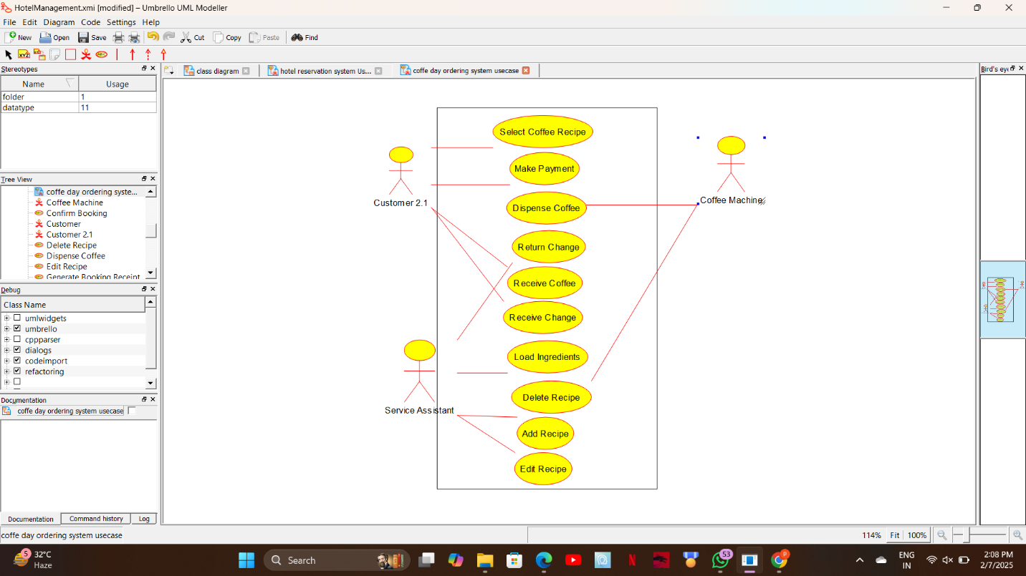

CLASS DIAGRAM:
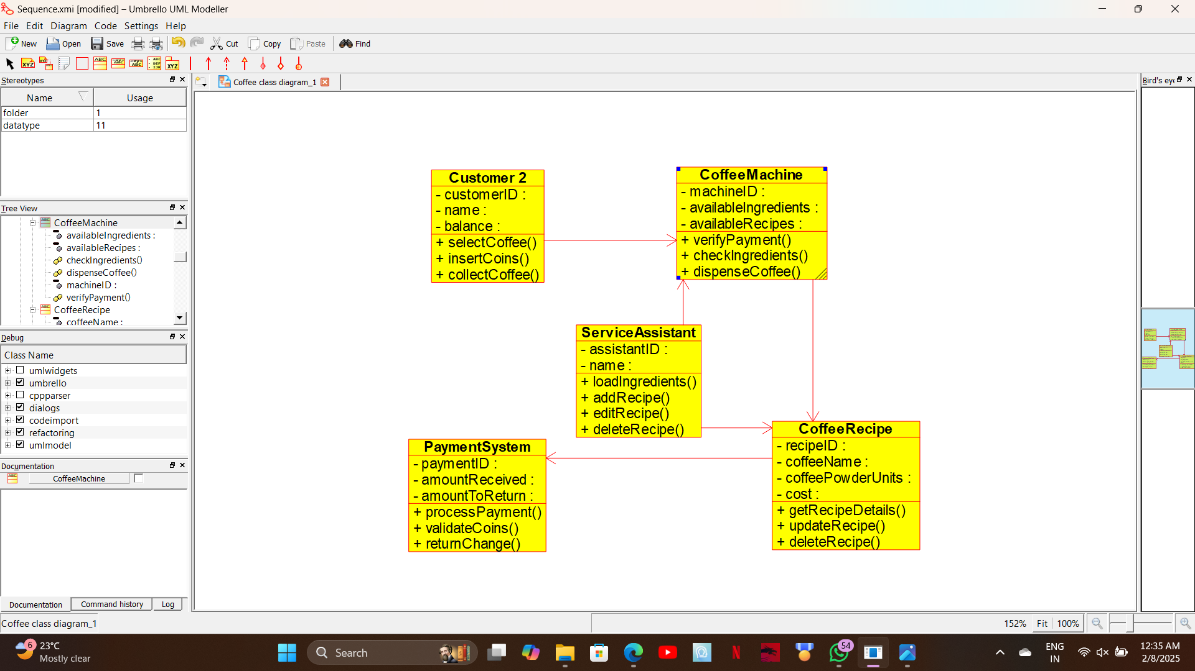
ACTIVITY DIAGRAM:
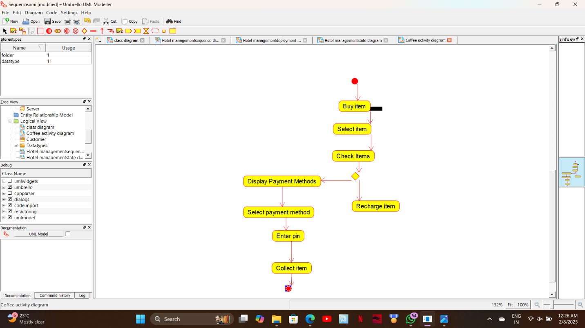

STATE DIAGRAM:
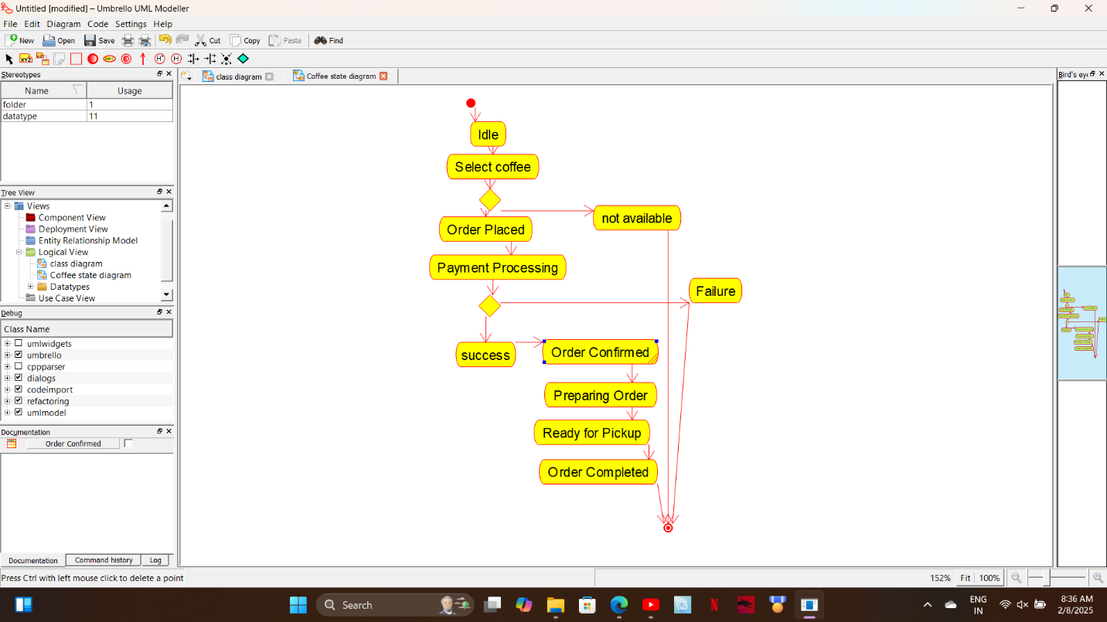

COLLABORATION DIAGRAM:
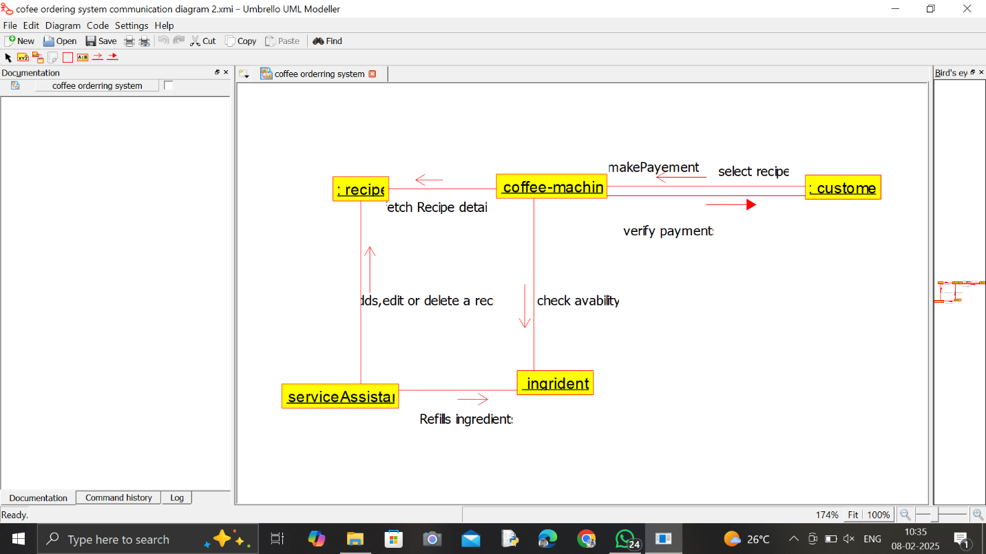

SEQUENCE DIAGRAM:
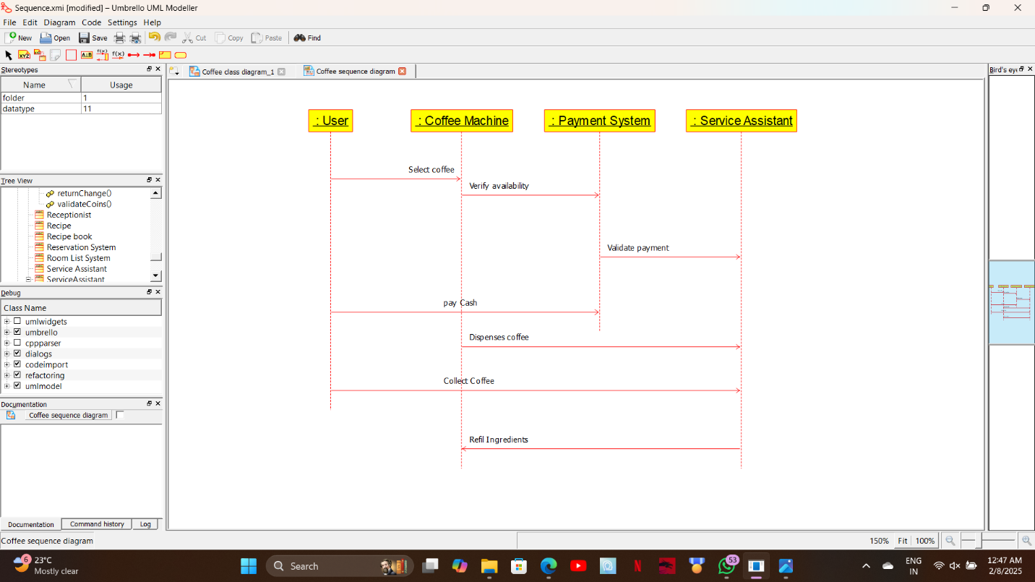

COMPONENT DIAGRAM:
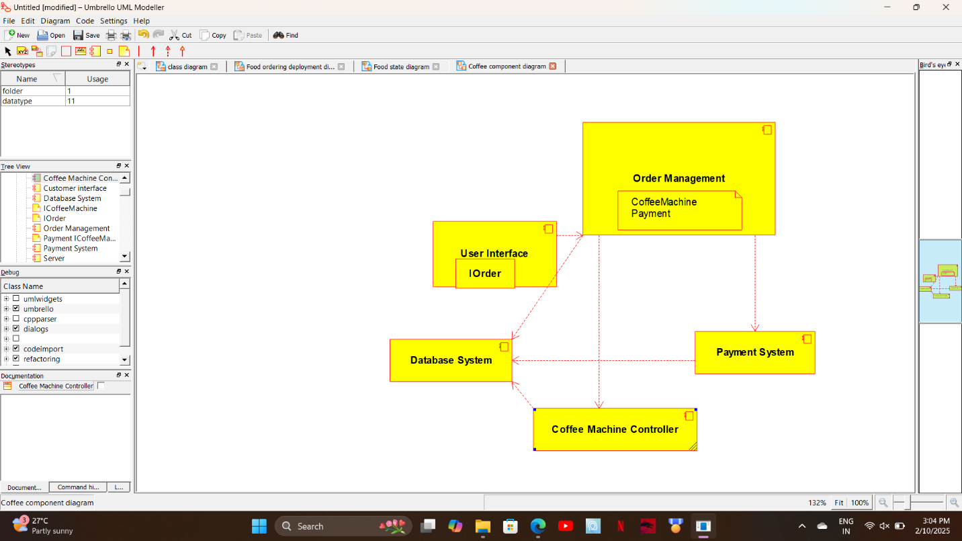

DEPLOYMENT DIAGRAM:
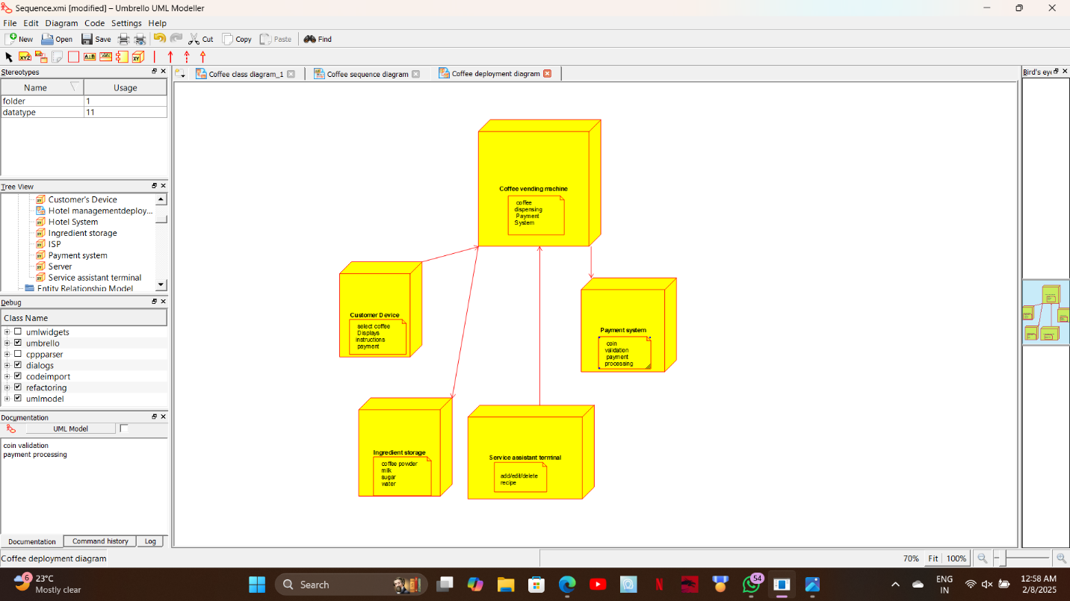

ER DIAGRAM:
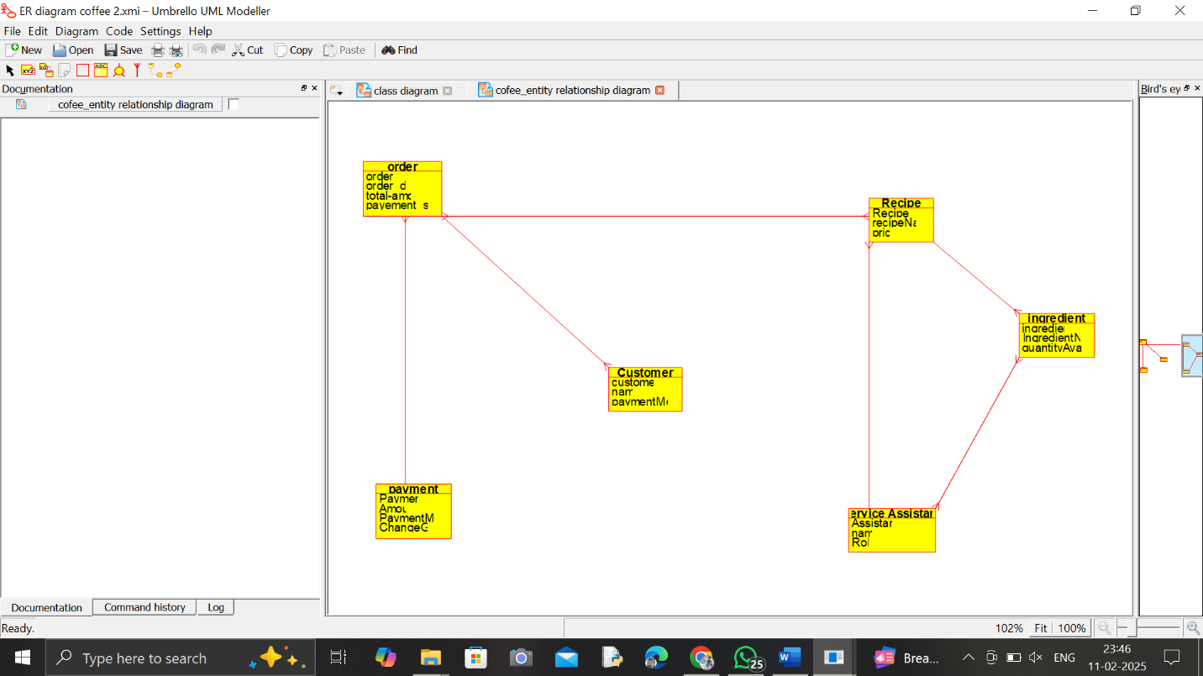

RESULT:

The Coffee Vending Machine System allows customers to select and pay for coffee, receiving change if applicable, while the Service Assistant manages ingredients and recipes. This ensures efficient coffee dispensing and smooth machine operations.

